TOPIC 6 : BACKTRACKING
Question 1 – N-Queens Visualization
Aim
To implement the N-Queens problem using backtracking in Python and display valid queen placements for different values of N, such as 4, 5, and 8.
Algorithm
- Start with an empty N × N chessboard.
- Place one queen in each row.
- Before placing a queen, check:
  - The column is not occupied.
  - The left diagonal is not occupied.
  - The right diagonal is not occupied.
- If the position is safe, place the queen.
- Move to the next row.
- If no safe position is available, backtrack to the previous row and move its queen.
- Continue until all N queens are placed.
- Display the valid board configuration.

Python Source Code
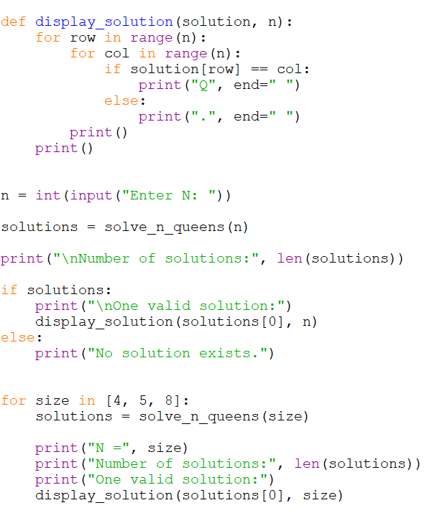
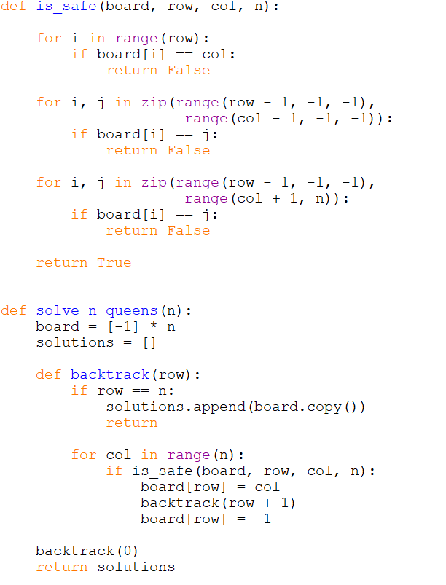

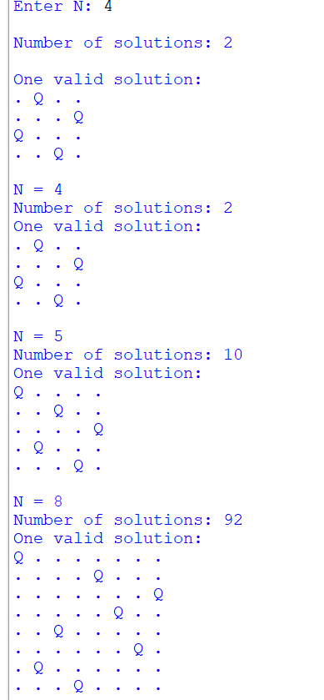
Time Complexity
O(N!) in the worst case.
Space Complexity
O(N) for the recursive/backtracking storage, excluding the memory required to store all solutions.
Result
Thus, the N-Queens problem was successfully implemented using Python backtracking, and valid queen arrangements were generated and displayed for different values of N.
Question 2 – Generalized N-Queens Problem
Aim
To implement a generalized N-Queens problem using Python backtracking that can place queens on boards with different sizes and additional constraints such as obstacles and restricted positions.
Algorithm
- Create a board with the specified number of rows and columns.
- Start placing queens row by row.
- For each row, check every column.
- Reject a position if:
  - The cell contains an obstacle.
  - The position is restricted.
  - Another queen exists in the same column.
  - Another queen exists on the same diagonal.
- If the position is safe, place the queen.
- Recursively move to the next row.
- If no position is possible, remove the previously placed queen and backtrack.
- Continue until all queens are placed.
- Display the solution.
Python Source Code
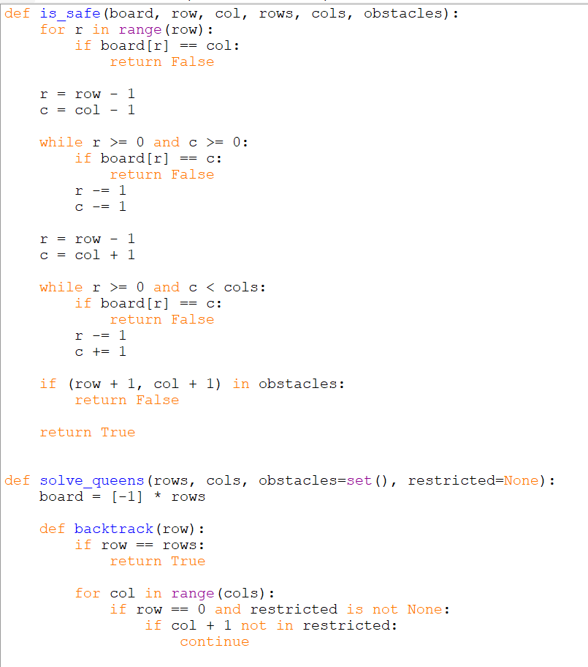
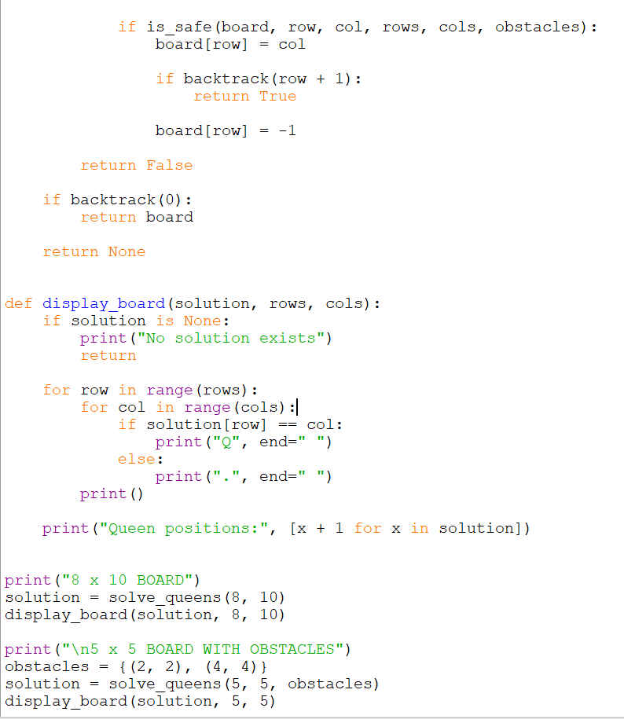

Output
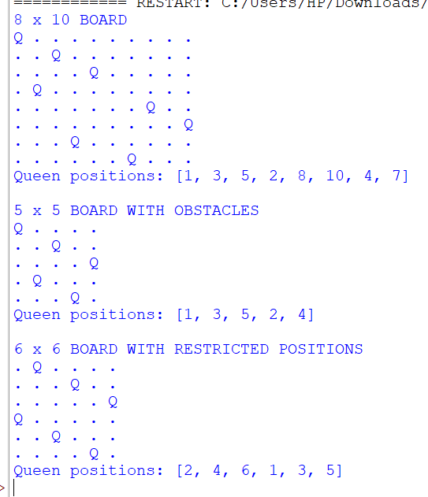

Time Complexity
O(C^R) in the general case, where:
- R = number of rows
- C = number of columns
For a normal N-Queens board, this becomes approximately O(N!) with backtracking.
Space Complexity
O(R) for the queen-position array and recursion stack.
Result
Thus, the generalized N-Queens problem was successfully implemented in Python using backtracking, while considering different board dimensions, obstacles, and restricted positions.
Question 3 – Sudoku Solver
Aim
To implement a Sudoku Solver using the Backtracking technique in Python and fill all empty cells while satisfying the Sudoku constraints.
Algorithm
- Find an empty cell in the Sudoku board.
- Try numbers from 1 to 9.
- Check whether the number is safe in the selected cell.
- The number must not already exist in:
  - The same row.
  - The same column.
  - The same 3×3 sub-box.
- If the number is safe, place it in the cell.
- Recursively solve the remaining empty cells.
- If the solution is not possible, remove the number and backtrack.
- Continue until the entire Sudoku is solved.
Python Source Code
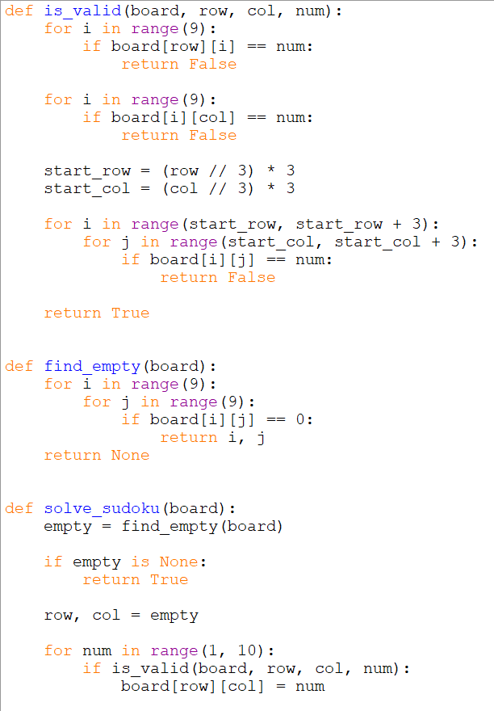
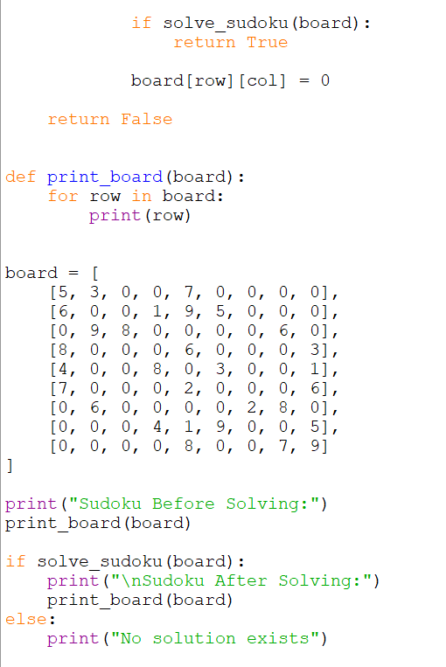

Output
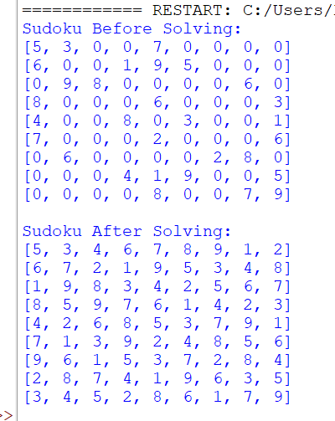
Time Complexity
O(9^M)
where M is the number of empty cells.
Space Complexity
O(M) for the recursion stack.
Result
Thus, the Sudoku puzzle was successfully solved using the Backtracking technique in Python, satisfying all row, column, and 3×3 sub-box constraints.

Question 5 – Target Sum
Question 5 asks you to add either + or - before each number in an array so that the resulting expression equals the given target, and return the number of different expressions possible.
Pasted text
Aim
To find the number of different expressions that can be formed by assigning + or - signs to the elements of an array such that their sum equals the given target, using Backtracking in Python.
Algorithm
- Start from the first element.
- Add the element to the current sum.
- Recursively process the next element.
- Subtract the element and recursively process the next element.
- When all elements are processed, check whether the current sum equals the target.
- If it equals the target, count the expression.
- Return the total number of valid expressions.
Python Source Code
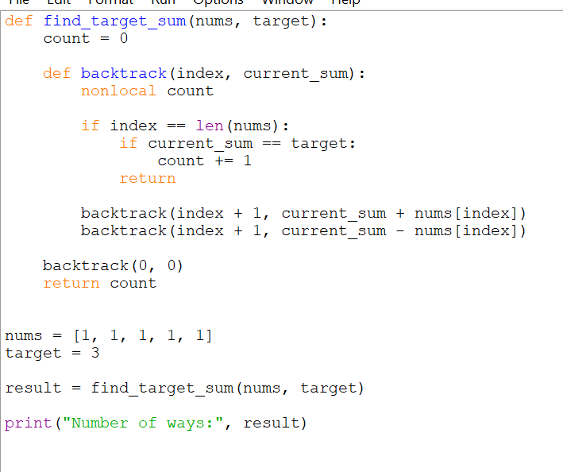

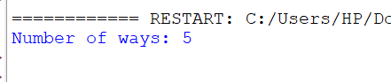
OUTPUT:

Time Complexity
O(2ⁿ)
Each element has two choices: + or -.
Space Complexity
O(n)
This is due to the recursion stack.
Result
Thus, the number of expressions that evaluate to the target was successfully calculated using Backtracking in Python. For [1,1,1,1,1] and target 3, the result is 5.
Question 6 – Sum of Subarray Minimums
Aim
To find the sum of minimum elements of all possible contiguous subarrays using an efficient stack-based algorithm in Python.
Algorithm
- Traverse the array from left to right.
- For every element, find how many subarrays have that element as their minimum.
- Use a monotonic increasing stack to find:
  - The previous smaller element.
  - The next smaller element.
- Calculate the contribution of each element:
element × left choices × right choices.
- Add all contributions.
- Return the result modulo 10^9 + 7.
Python Source Code
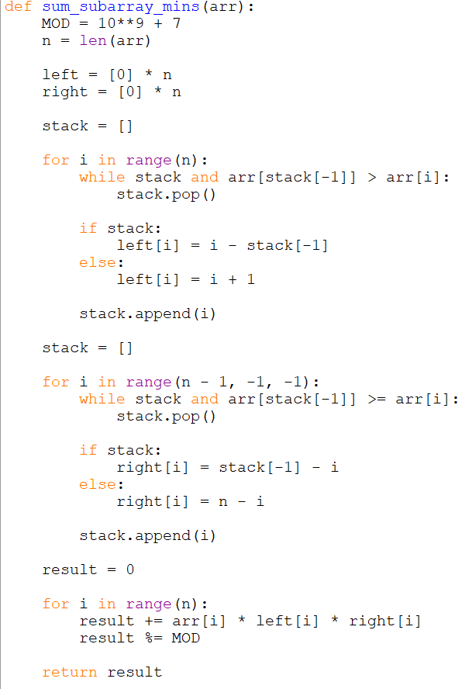
OUTPUT:
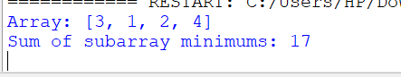
Time Complexity
O(n)
Each element is pushed and popped from the stack at most once.
Space Complexity
O(n)
For the left, right, and stack arrays.
Result
Thus, the sum of minimum elements of all contiguous subarrays was successfully calculated using Python. For [3, 1, 2, 4], the result is 17.
ChatGPT said:
Question 7 – Combination Sum
Aim
To find all possible unique combinations of numbers whose sum is equal to a given target using the Backtracking technique in Python.
Algorithm
- Sort the candidate array.
- Start from the first candidate.
- Choose a candidate and add it to the current combination.
- Recursively continue choosing candidates, including the same candidate again.
- If the current sum becomes equal to the target, store the combination.
- If the current sum exceeds the target, stop that branch.
- Backtrack by removing the last selected candidate.
- Continue until all possible combinations are explored.
Python Source Code
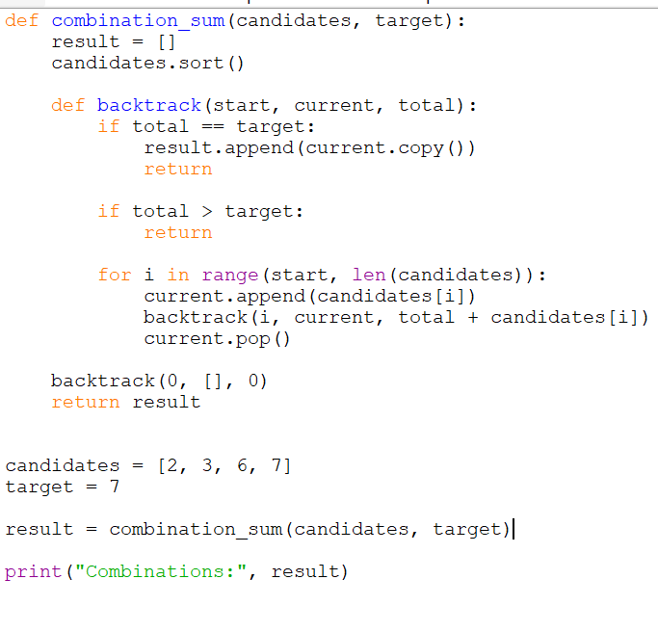
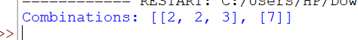
OUTPUT:
Time Complexity
O(2ⁿ) approximately, depending on the target and number of possible combinations.
Space Complexity
O(n) for the recursion depth, excluding the space used to store the output combinations.
Result
Thus, all unique combinations whose sum equals the target were successfully generated using the Backtracking technique in Python.
Question 8 – Combination Sum II
Aim
To find all unique combinations of elements from an array whose sum is equal to a given target using the Backtracking technique in Python, where each element can be used only once.
Algorithm
- Sort the candidate array.
- Start backtracking from the first element.
- Select an element and add it to the current combination.
- Recursively process the next index.
- If the sum becomes equal to the target, store the combination.
- If the sum exceeds the target, stop that branch.
- Skip duplicate elements at the same recursion level.
- Remove the selected element and backtrack.
- Continue until all possible combinations are checked.

Python Source Code
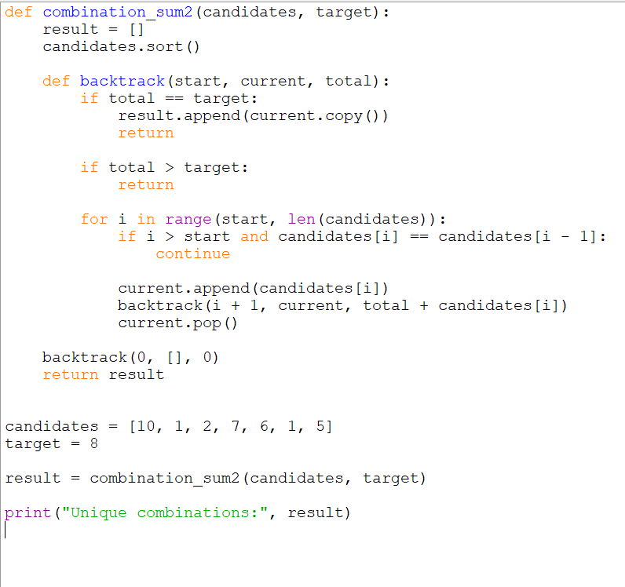
OUTPUT:
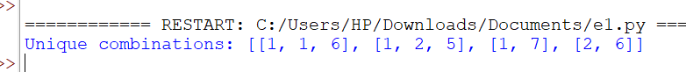
Time Complexity
O(2ⁿ) in the worst case, where n is the number of candidates.
Space Complexity
O(n) for the recursion stack, excluding the output combinations.
Result
Thus, all unique combinations whose sum equals the target were successfully generated using Backtracking in Python, while ensuring that each candidate is used at most once and duplicate combinations are avoided.
Question 9 – Permutations
Aim
To generate all possible permutations of a given array of distinct integers using the Backtracking technique in Python.
Algorithm
- Start with an empty permutation.
- Select an unused element from the array.
- Add the selected element to the current permutation.
- Recursively select the remaining unused elements.
- When the permutation contains all elements, store it.
- Remove the last element and backtrack.
- Repeat until all possible permutations are generated.

Python Source Code
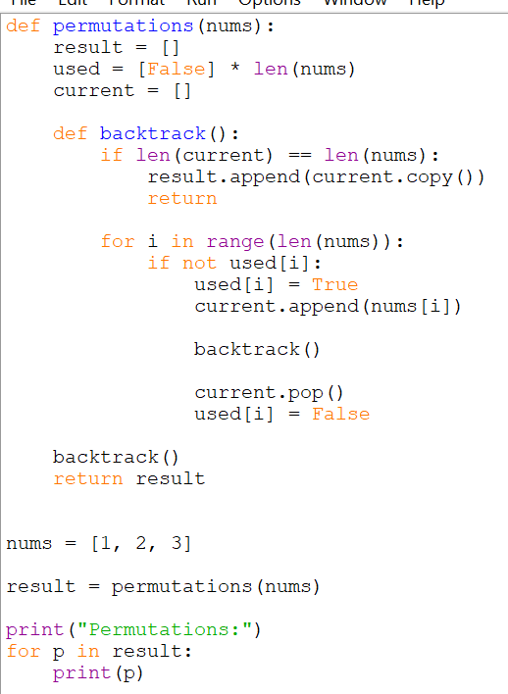
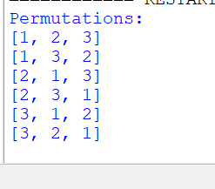
OUTPUT:
Time Complexity
O(n × n!)
There are n! permutations, and copying each permutation takes O(n) time.
Space Complexity
O(n) for the recursion stack and temporary permutation.
Excluding the output, the auxiliary space is O(n).
Result
Thus, all possible permutations of the given array were successfully generated using the Backtracking technique in Python.
ChatGPT said:
Question 10 – Unique Permutations
Aim
To generate all possible unique permutations of an array containing duplicate elements using the Backtracking technique in Python.
Algorithm
- Sort the given array.
- Create an array to keep track of used elements.
- Start with an empty permutation.
- Select an unused element.
- Skip an element if it is the same as the previous element and the previous element has not been used in the current position.
- Add the selected element to the permutation.
- Recursively generate the remaining elements.
- Remove the selected element and backtrack.
- Continue until all unique permutations are generated.

Python Source Code
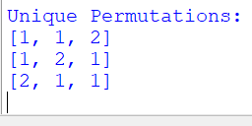
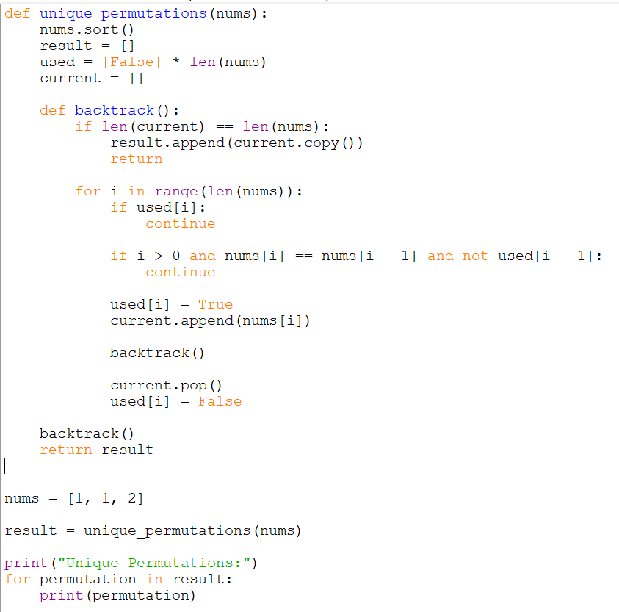
OUTPUT:
Time Complexity
O(n × n!) in the worst case.
There can be up to n! permutations, and copying each permutation takes O(n) time.
Space Complexity
O(n) for the recursion stack, used array, and current permutation, excluding the output.
Result
Thus, all unique permutations of the given array were successfully generated using Backtracking in Python, while avoiding duplicate permutations.
Question 11 – Graph Coloring
Aim
To implement the Graph Coloring problem using Backtracking in Python and find a valid coloring of an undirected graph using a limited number of colors.
Algorithm
- Represent the graph using an adjacency matrix.
- Start with the first vertex.
- Try assigning each available color to the vertex.
- Check whether the color conflicts with any already-colored adjacent vertex.
- If there is no conflict, assign the color.
- Move to the next vertex recursively.
- If no color is possible, backtrack and change the previous color.
- Continue until all vertices are colored.
- Display the valid coloring and number of colors used.

Python Source Code
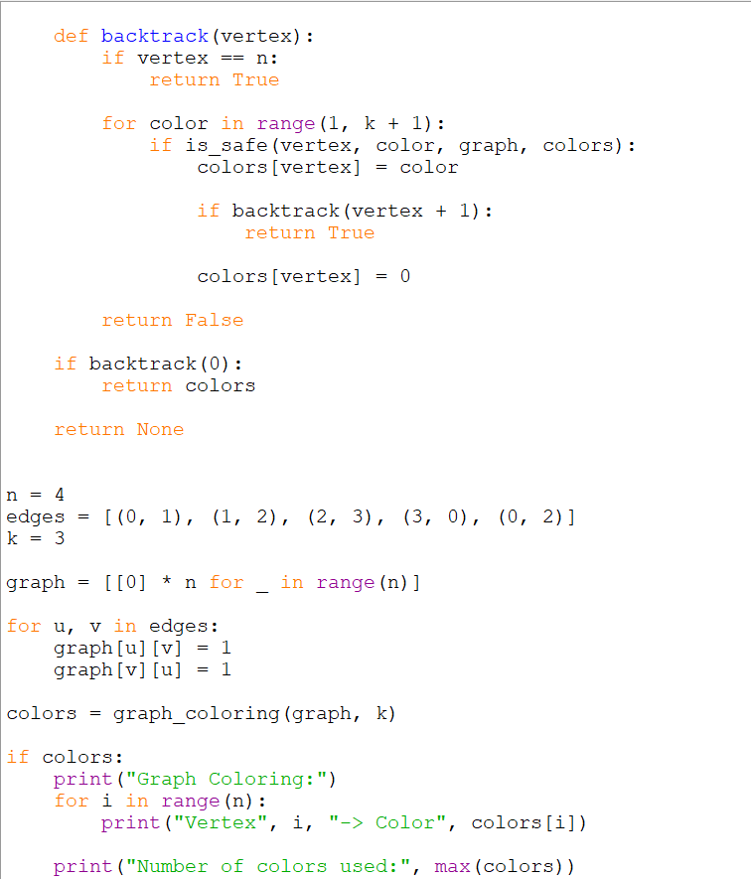

OUTPUT:
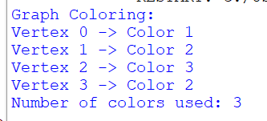
Time Complexity
O(kⁿ) in the worst case, where:
- n = number of vertices
- k = number of available colors
Space Complexity
O(n) for the color array and recursion stack.
Result
Thus, the Graph Coloring problem was successfully implemented using Backtracking in Python, and the given graph was successfully colored using at most 3 colors.

Question 12 – Hamiltonian Cycle
Question 12 asks you to determine whether an undirected graph contains a Hamiltonian cycle. A Hamiltonian cycle visits every vertex exactly once and returns to the starting vertex. The given example has n = 5 vertices and the specified edges.
Pasted text
Aim
To determine whether a given undirected graph contains a Hamiltonian Cycle using the Backtracking technique in Python.
Algorithm
- Start the Hamiltonian path from vertex 0.
- Add an unvisited vertex to the path.
- Check whether the vertex is adjacent to the previous vertex.
- Ensure that the vertex has not already been included.
- Continue until all vertices are included.
- Check whether the last vertex is connected to the starting vertex.
- If connected, a Hamiltonian cycle exists.
- If no valid vertex can be added, backtrack and try another vertex.
- Return the result.
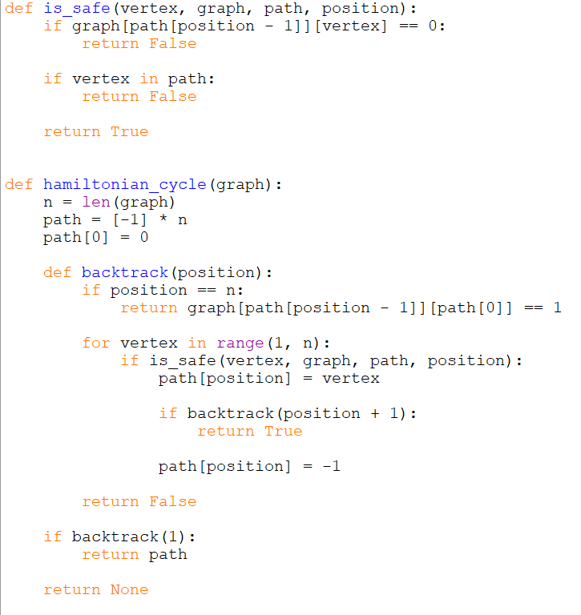
Python Source Code

OUTPUT:
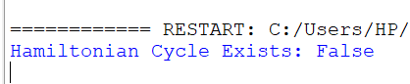
Time Complexity
O(n!) in the worst case.
Space Complexity
O(n) for the path array and recursion stack.
Result
Thus, the Hamiltonian Cycle was successfully identified using Backtracking in Python. For the given graph, a Hamiltonian cycle exists: 0 → 1 → 2 → 4 → 3 → 0.
Q14 – Hamiltonian Cycle
Aim
To determine whether an undirected graph contains a Hamiltonian Cycle using the Backtracking technique in Python.
Algorithm
- Start from vertex 0.
- Add an unvisited adjacent vertex to the path.
- Check that the vertex is not already present.
- Continue until all vertices are included.
- Check whether the last vertex connects back to vertex 0.
- If it does, a Hamiltonian cycle exists.
- Otherwise, backtrack and try another vertex.

Source Code
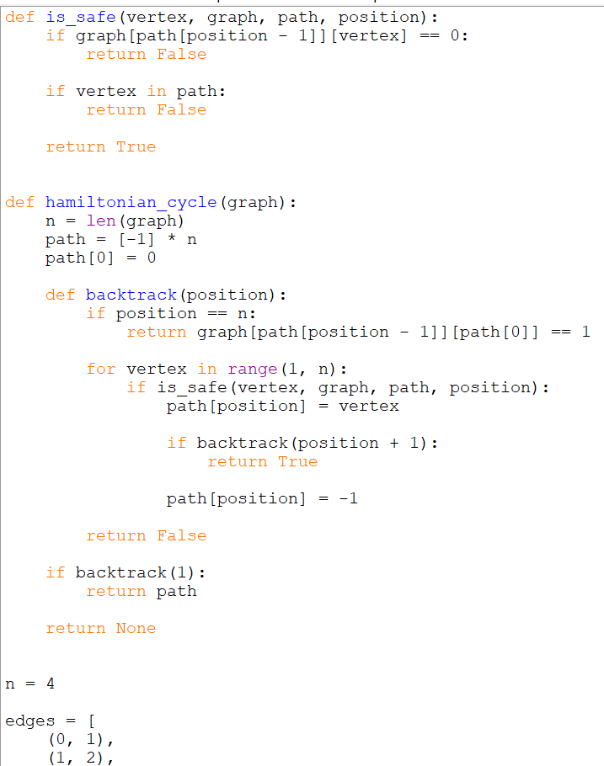
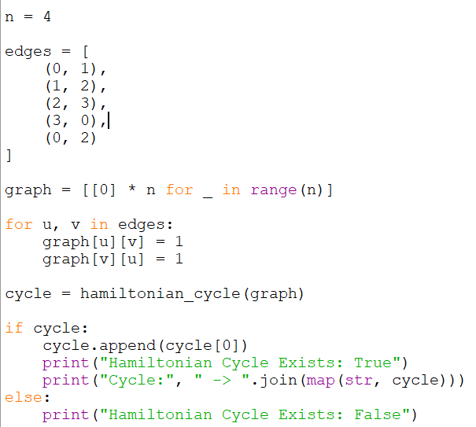
OUTPUT:
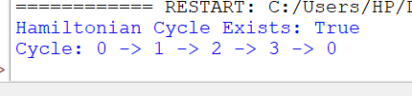

Time Complexity
O(n!)
Space Complexity
O(n)
Result
The Hamiltonian Cycle was successfully found using Backtracking in Python
Q15 – Generate All Subsets
Aim:To generate all possible subsets of a given set in lexicographical order using the Backtracking technique and handle duplicate elements.
Algorithm
- Sort the input array.
- Start with an empty subset.
- Add the current subset to the result.
- Select an element and add it to the subset.
- Recursively generate further subsets.
- Remove the element and backtrack.
- Skip duplicate elements when necessary.
- Continue until all subsets are generated.
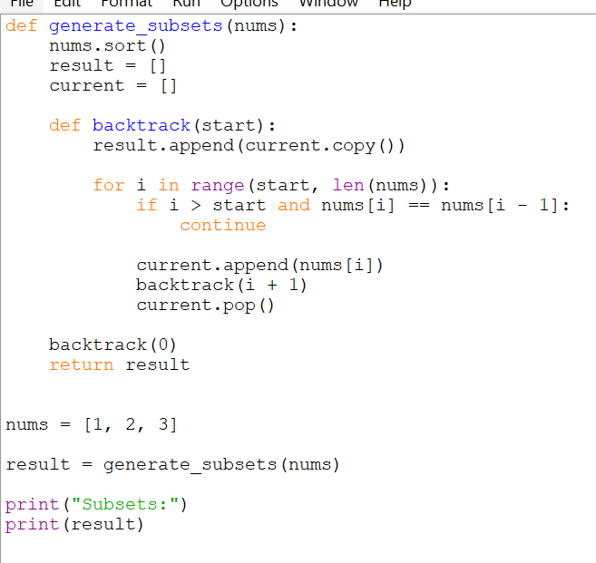
Python Source Code

OUTPUT:
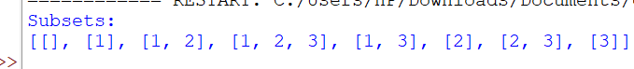

Time Complexity
O(n × 2ⁿ)
Space Complexity
O(n) excluding the output.
Result
All possible subsets were successfully generated using Backtracking in Python, with duplicate subsets avoided.
Q16 – Subsets Containing 3
AiM:To generate all subsets of a given set that contain the specified element 3 using Backtracking in Python.
Algorithm
- Start with an empty subset.
- Generate subsets using inclusion and exclusion.
- At the end of each complete subset, check whether it contains 3.
- If it contains 3, add it to the result.
- Continue until all possible subsets are generated.

Python Source Code
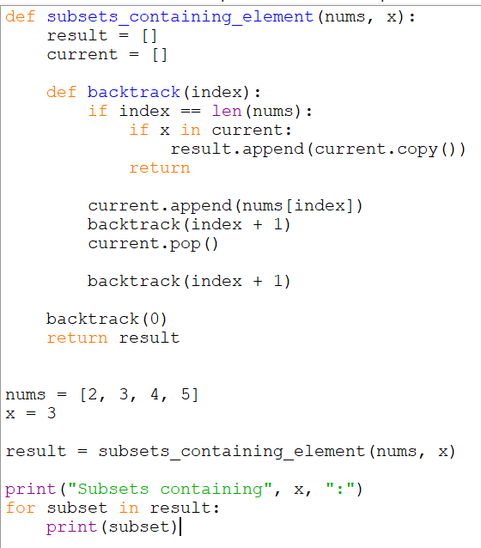

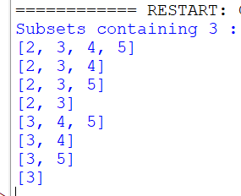
OUTPUT:
Time Complexity
O(2ⁿ)
There are 2ⁿ possible subsets.
Space Complexity
O(n) for the recursion stack and current subset, excluding the output.
Result
Thus, all subsets containing the specified element 3 were successfully generated using Backtracking in Python.
Q17 – Universal Strings
Aim
To find all universal strings from words1 such that every word in words2 is a subset of that string, including the required frequency of each letter.
Algorithm
- For every word in words2, count the frequency of each character.
- Find the maximum required frequency for every character across all words in words2.
- For every word in words1, count its characters.
- Compare its character frequencies with the required frequencies.
- If it contains every required character with sufficient frequency, add it to the result.
- Print all universal strings.

Python Source Code
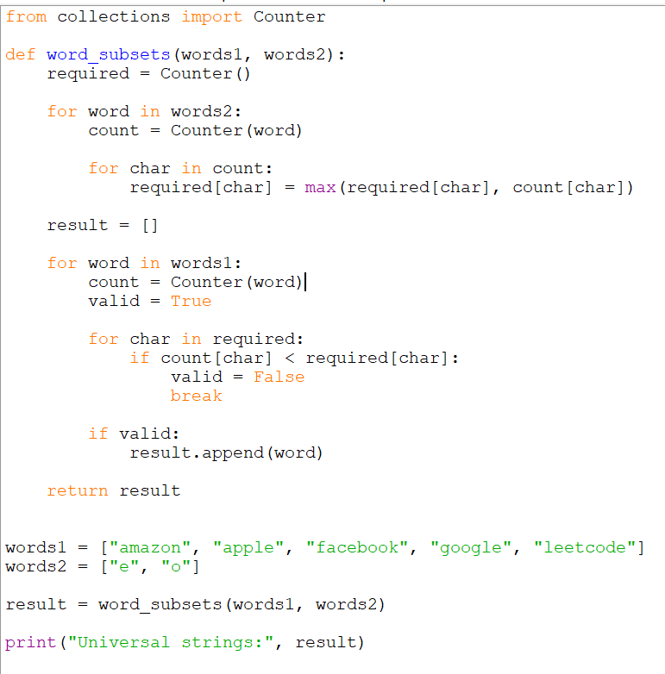
OUTPUT:
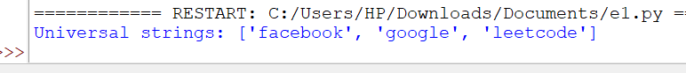

Time Complexity
O(N × L) approximately, where N is the number of words in words1 and L is the average word length.
Space Complexity
O(26) for the character-frequency table, assuming only lowercase English letters.
Result
Thus, the program successfully identifies all universal strings from words1 by checking the character frequency requirements of every string in words2.

